Cara memasukan file vs code ke git hub

|  |
| --- |
| Lenovo@Reza-p MINGW64 /d/@itenas/latihan web/nyoba  $ cd langkah-langkah-menjadi-programer/  Lenovo@Reza-p MINGW64 /d/@itenas/latihan web/nyoba/langkah-langkah-menjadi-programer (main)  $ git add apadeh.py  Lenovo@Reza-p MINGW64 /d/@itenas/latihan web/nyoba/langkah-langkah-menjadi-programer (main)  $ git commit -m "aku baru bikin file apadeh.py"  [main cdff03c] aku baru bikin file apadeh.py  1 file changed, 1 insertion(+)  create mode 100644 apadeh.py  Lenovo@Reza-p MINGW64 /d/@itenas/latihan web/nyoba/langkah-langkah-menjadi-programer (main)  $ git push origin main  fatal: unable to access 'https://github.com/rz31a/langkah-langkah-menjadi-programer.git/': Failed to connect to github.com port 443 after 21153 ms: Could not connect to server  Lenovo@Reza-p MINGW64 /d/@itenas/latihan web/nyoba/langkah-langkah-menjadi-programer (main)  $ git push origin main  info: please complete authentication in your browser...  Enumerating objects: 4, done.  Counting objects: 100% (4/4), done.  Delta compression using up to 12 threads  Compressing objects: 100% (2/2), done.  Writing objects: 100% (3/3), 356 bytes | 356.00 KiB/s, done.  Total 3 (delta 0), reused 0 (delta 0), pack-reused 0 (from 0)  To https://github.com/rz31a/langkah-langkah-menjadi-programer.git  c052aaf..cdff03c main -> main  Lenovo@Reza-p MINGW64 /d/@itenas/latihan web/nyoba/langkah-langkah-menjadi-programer (main)  $ git add tambah.py  Lenovo@Reza-p MINGW64 /d/@itenas/latihan web/nyoba/langkah-langkah-menjadi-programer (main)  $ git commit -m 'program tambah'  [main df3a634] program tambah  1 file changed, 4 insertions(+)  create mode 100644 tambah.py  Lenovo@Reza-p MINGW64 /d/@itenas/latihan web/nyoba/langkah-langkah-menjadi-programer (main)  Lenovo@Reza-p MINGW64 /d/@itenas/latihan web/nyoba/langkah-langkah-menjadi-programer (main)  $ git push origin main  Enumerating objects: 4, done.  Counting objects: 100% (4/4), done.  Delta compression using up to 12 threads  Compressing objects: 100% (2/2), done.  Writing objects: 100% (3/3), 295 bytes | 295.00 KiB/s, done.  Total 3 (delta 1), reused 0 (delta 0), pack-reused 0 (from 0)  remote: Resolving deltas: 100% (1/1), completed with 1 local object.  To https://github.com/rz31a/langkah-langkah-menjadi-programer.git  cdff03c..df3a634 main -> main  Lenovo@Reza-p MINGW64 /d/@itenas/latihan web/nyoba/langkah-langkah-menjadi-programer (main)  $ |

Cara

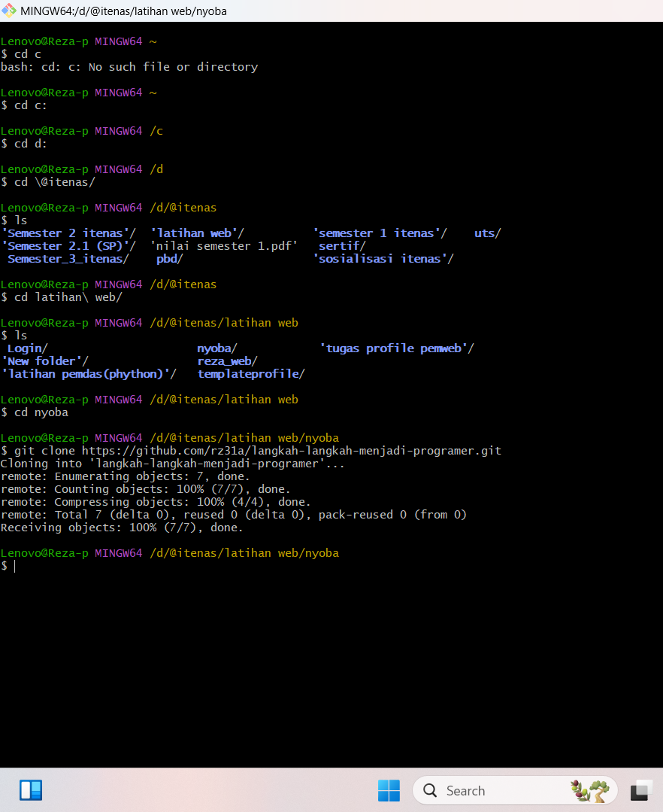

|  |
| --- |
| Lenovo@Reza-p MINGW64 ~  $ cd c  bash: cd: c: No such file or directory  Lenovo@Reza-p MINGW64 ~  $ cd c:  Lenovo@Reza-p MINGW64 /c  $ cd d:  Lenovo@Reza-p MINGW64 /d  $ cd \@itenas/  Lenovo@Reza-p MINGW64 /d/@itenas  $ ls  **'Semester 2 itenas'**/ **'latihan web'**/ **'semester 1 itenas'**/ **uts**/  **'Semester 2.1 (SP)'**/ 'nilai semester 1.pdf' **sertif**/  **Semester_3_itenas**/ **pbd**/ **'sosialisasi itenas'**/  Lenovo@Reza-p MINGW64 /d/@itenas  $ cd latihan\ web/  Lenovo@Reza-p MINGW64 /d/@itenas/latihan web  $ ls  **Login**/ **nyoba**/ **'tugas profile pemweb'**/  **'New folder'**/ **reza_web**/  **'latihan pemdas(phython)'**/ **templateprofile**/  Lenovo@Reza-p MINGW64 /d/@itenas/latihan web  $ cd nyoba  Lenovo@Reza-p MINGW64 /d/@itenas/latihan web/nyoba  $ git clone https://github.com/rz31a/langkah-langkah-menjadi-programer.git Cloning into 'langkah-langkah-menjadi-programer'...  remote: Enumerating objects: 7, done.  remote: Counting objects: 100% (7/7), done.  remote: Compressing objects: 100% (4/4), done.  remote: Total 7 (delta 0), reused 0 (delta 0), pack-reused 0 (from 0)  Receiving objects: 100% (7/7), done.  Lenovo@Reza-p MINGW64 /d/@itenas/latihan web/nyoba  $ |